- Abdulrahman Ayman Mohamed
- Abdulrahman Hamed Mohamed
- Habiba Mohamed Hemdan
- Hana Mohamed Yahia
- Haneen Atef Mohamed
- Momen Mohamed Mosaad
- Reham Khaled Fathy Greish
- Zeyad Mohamad Asaad

Path Loss &Coverage
SUBMITTED TO:PROF.DR.HASSAN AL MAHDI

1. Introduction
The wireless channel is the medium—typically air—that conveys information from a transmitter to a receiver. Path loss is critical because it dictates the reduction in signal power over distance, which directly affects the system's coverage and reliability. Path loss is a form of attenuation, the general reduction in signal magnitude. Key components of attenuation include spreading loss (where energy density decreases as the wave propagates) and losses due to the environment. Antenna gain (G_t, G_r) measures an antenna's ability to focus or capture energy in a specific direction relative to an isotropic source.

2. Theory Summary (From Lecture)
- Friis Transmission Equation
- The Friis transmission equation describes the received power in a free-space, line-of-sight (LOS) wireless channel. It assumes no obstacles, no reflections, and ideal propagation conditions.
$$P_{r}=P_{t} G_{t} G_{r}{\left(\frac{λ}{4πd}\right)}^{2}$$
Where:
- $P_{r}$= received power
- $P_{t}$= transmitted power
- $G_{t}$= transmitter antenna gain
- $G_{r}$= receiver antenna gain
- $λ$= wavelength
- $d$= distance between transmitter and receiver
This equation shows that the received power decreases with the square of the distance and depends on the operating frequency through the wavelength.

- Path Loss in Free Space (dB)
Path loss is defined as the ratio between the transmitted power $P_{t}$and the received power $P_{r}$:
$$PL=\frac{P_{t}}{P_{r}}$$
Using the Friis transmission equation:
$$P_{r}=P_{t}G_{t}G_{r}{\left(\frac{λ}{4πd}\right)}^{2}$$
where:
- $G_{t}$and $G_{r}$are the transmitter and receiver antenna gains,
- $λ$is the wavelength,
- $d$is the distance between antennas.
Substituting $P_{r}$into the path loss equation:
$$PL=\frac{P_{t}}{P_{t}G_{t}G_{r}{\left(\frac{λ}{4πd}\right)}^{2}}=\frac{1}{G_{t}G_{r}}{\left(\frac{4πd}{λ}\right)}^{2}$$
Step 1: Assume Unit-Gain Antennas
For isotropic antennas, $G_{t}=G_{r}=1$, the expression simplifies to:
$$PL={\left(\frac{4πd}{λ}\right)}^{2}$$
Step 2: Convert to Decibel (dB) Scale
Path loss in decibels is given by:
$$PL_{dB}=10{log⁡}_{10}(PL)=10{log⁡}_{10}{\left(\frac{4πd}{λ}\right)}^{2}=20{log⁡}_{10}\left(\frac{4πd}{λ}\right)$$
Step 3: Expand the Logarithm
$$PL_{dB}=20{log⁡}_{10}(4π)+20{log⁡}_{10}(d)-20{log⁡}_{10}(λ)$$
Step 4: Express Wavelength in Terms of Frequency
Since $λ=\frac{c}{f}$, we have:
$$-20{log⁡}_{10}(λ)=20{log⁡}_{10}(f)-20{log⁡}_{10}(c)$$
Substituting this into the path loss expression:
$$PL_{dB}=20{log⁡}_{10}(d)+20{log⁡}_{10}(f)+20{log⁡}_{10}\left(\frac{4π}{c}\right)$$
This is the free-space path loss formula in decibels, which depends on distance $d$and frequency $f$.
Relationship to the Friis Equation
Free-space path loss is derived directly from the Friis equation:
$$PL=\frac{P_{t}}{P_{r}}$$
By taking the logarithm, we get the free-space path loss formula in dB.

- 2-Ray Ground Reflection Model
- The 2-Ray Ground Reflection Model is used to estimate the received signal power in wireless communications when both a direct line-of-sight (LOS) path and a ground-reflected path exist. It accounts for interference between these two paths.
- Accurate than the simpler free-space model, which only accounts for the LOS path.
For large distances (far-field), the received power is approximated by:
$$P_{r}=P_{t}G_{t}G_{r}{\left(\frac{h_{t}h_{r}}{d^{2}}\right)}^{2}$$
Where:
- $h_{t}$: transmitter antenna height (m)
- $h_{r}$: receiver antenna height (m)
- $d$: distance between transmitter and receiver (m)

- Receiver Sensitivity
Receiver sensitivity is the minimum received signal power required for a receiver to successfully decode the transmitted signal.
Key points:
- It is usually expressed in dBm
- If received power is below sensitivity, communication fails
Factors affecting receiver sensitivity:
- Noise level (thermal noise, interference)
- Bandwidth
- Modulation and coding scheme
- Required Signal-to-Noise Ratio (SNR)
Example:
- Bluetooth receivers typically require sensitivity between –70 dBm and –82 dBm

3)Numerical Example (Lecture Rule)
Given Rule (from the lecture)
$$40{log⁡}_{10}(d)-10{log⁡}_{10}(G_{t})-10{log⁡}_{10}(G_{r})-20{log⁡}_{10}(h_{t})-20{log⁡}_{10}(h_{r})=pl$$
Objective:
To calculate the received power $P_{r}$.

Given Parameters
- Distance between transmitter and receiver:
$$d=500\text{ m}$$
- Transmit power:
$$P_{t}=30\text{ dBm}$$
- Transmitter antenna gain:
$$G_{t}=1$$
- Receiver antenna gain:
$$G_{r}=1$$
- Transmitter (base station) antenna height:
$$h_{t}=10\text{ m}$$
- Receiver (user equipment) antenna height:
$$h_{r}=1$$

Step 1: Substitute the values into the formula
$$40{log⁡}_{10}(500)-10{log⁡}_{10}(1)-10{log⁡}_{10}(1)-20{log⁡}_{10}(10)-20{log⁡}_{10}(1)=pl$$

Step 2: Evaluate the logarithmic terms
$${log⁡}_{10}(500)≈2.699 \\ 40×2.699≈108 \\ 10{log⁡}_{10}(1)=0 \\ 20{log⁡}_{10}(10)≈20$$

Step 3: Simplify the equation
$$108-0-0-20-0=pl \\ 108-20=pl \\ 88=pl$$

Step 4: Solve for the received power
$$pl=pt-pr$$
88 $=$ 30 $-pr$

Final Answer
$$\boxed{P_{r}≈-58\text{ dBm}}$$

Interpretation
- The received power at the user is approximately –58 dBm.
- If the receiver sensitivity is –82 dBm, the received signal is above the sensitivity threshold, so the signal can be successfully decoded.
- If the receiver sensitivity is –50 dBm, the received signal is below the required threshold, and therefore the signal cannot be decoded.

4. Discussion
Free-Space Model: Why It Does Not Work Well in Real Life
The Free-Space Model is a very simple way to explain how wireless signals travel. It assumes a perfect situation where a signal moves in a straight line from the transmitter to the receiver without hitting anything along the way. In this imaginary world, there are no buildings, trees, people, or even the ground to block or reflect the signal.
According to this model, the signal becomes weaker as the distance increases. The farther the receiver is from the transmitter, the lower the signal strength will be. This decrease follows a simple rule: when the distance increases by a large amount, the signal strength drops by a fixed amount. While this idea is easy to understand, it is also the main weakness of the Free-Space Model.
In real life, wireless signals almost never travel in such a clean and perfect way. In cities, signals bounce off buildings, vehicles, and walls. Even in open areas, signals reflect off the ground and are affected by the environment. Weather conditions, such as rain, and people moving around can also change how signals behave. All of these effects cause the signal to weaken more than the Free-Space Model predicts.
Because the Free-Space Model ignores these real-world effects, it often gives results that are too optimistic. For example, it may predict that a signal is still strong at a certain distance, when in reality the signal is much weaker or unstable. This is why the Free-Space Model is usually only accurate for very short distances, clear open paths, or communication in space, such as satellite links.

2-Ray Model: A More Realistic Approach
The 2-Ray Model improves on the Free-Space Model by including one important real-world effect: ground reflection. Instead of assuming the signal travels only one straight path, this model assumes the signal reaches the receiver in two ways. One path is direct, and the second path comes from the signal bouncing off the ground.
Because the signal arrives through two paths, the two versions of the signal can interact with each other. Sometimes they add together and make the signal stronger, but other times they cancel each other out and make the signal weaker. As the distance between the transmitter and receiver increases, this interference becomes more significant, causing the signal to fade faster than predicted by the Free-Space Model.
In practical systems such as mobile phone networks, ground reflections play a major role. The height of the base station, the height of the mobile phone, and the distance between them all affect how strong the received signal will be. The 2-Ray Model takes these factors into account, making it much better suited for real-world wireless communication systems.

Why the Free-Space Model Overestimates Signal Strength
One of the biggest problems with the Free-Space Model is that it often predicts a signal to be stronger than it really is, especially at long distances. There is a certain distance where ground reflections start to strongly affect the signal. Before this point, the Free-Space Model may give reasonable results, but beyond it, the predictions become unreliable.
In real environments, signals usually travel along multiple paths before reaching the receiver. These multiple paths cause delays and changes in signal timing, which can distort the signal. This effect is known as multipath propagation and can lead to fading and interference. The Free-Space Model assumes only one signal path, so it completely ignores these issues.
Because of this, engineers who rely only on the Free-Space Model may design systems that do not work well in practice. The signal coverage may be smaller than expected, leading to weak signal areas, dropped calls, or slow data speeds. Using a more realistic model helps avoid these problems.
Conclusion
In summary, the Free-Space Model is useful for learning basic concepts and understanding how signals behave in ideal conditions. However, it is too simple for designing real-world wireless communication systems. The 2-Ray Model provides a more accurate picture by including ground reflections and interference effects.
For modern technologies such as 4G, 5G, and future wireless systems, realistic models are essential. Starting with models like the 2-Ray Model helps engineers build reliable networks that perform well in everyday environments.

Run of program:
Imports &GUI
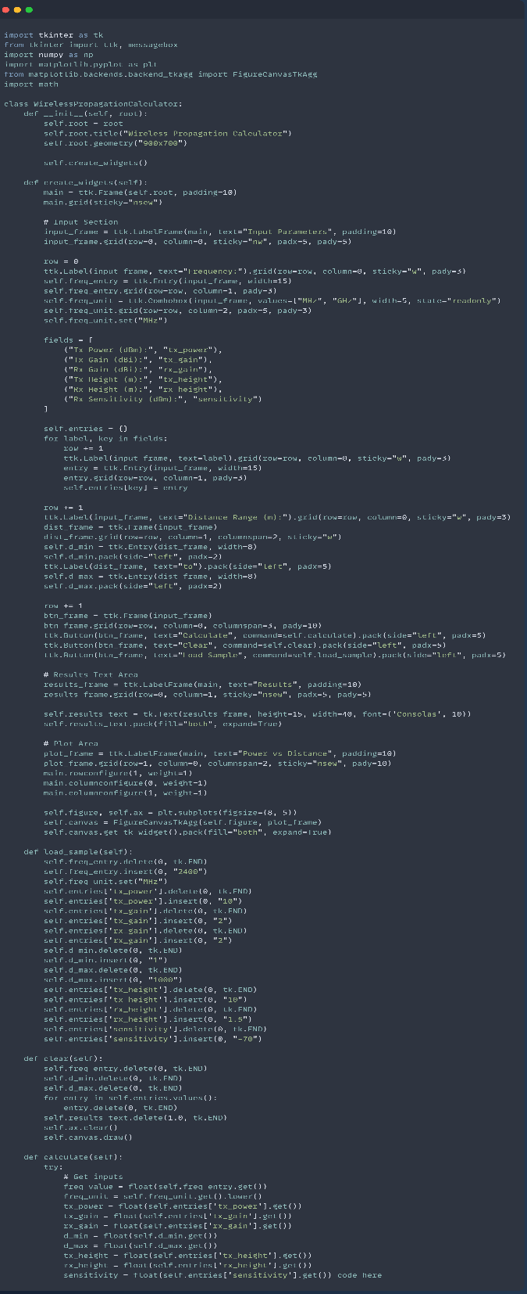

Functionalities & Plotting

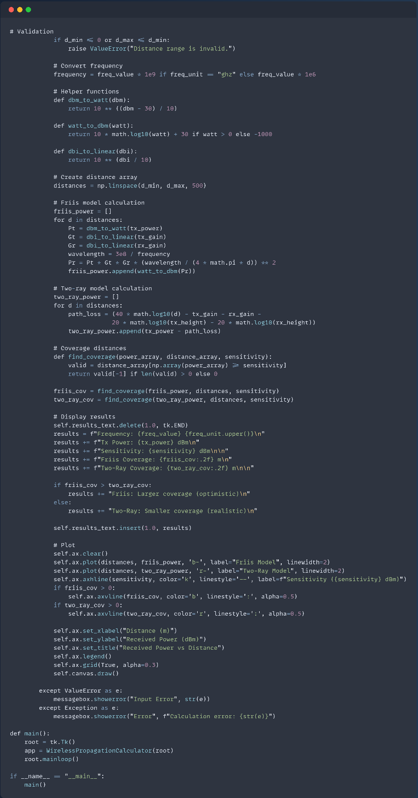

Results and Interpretations
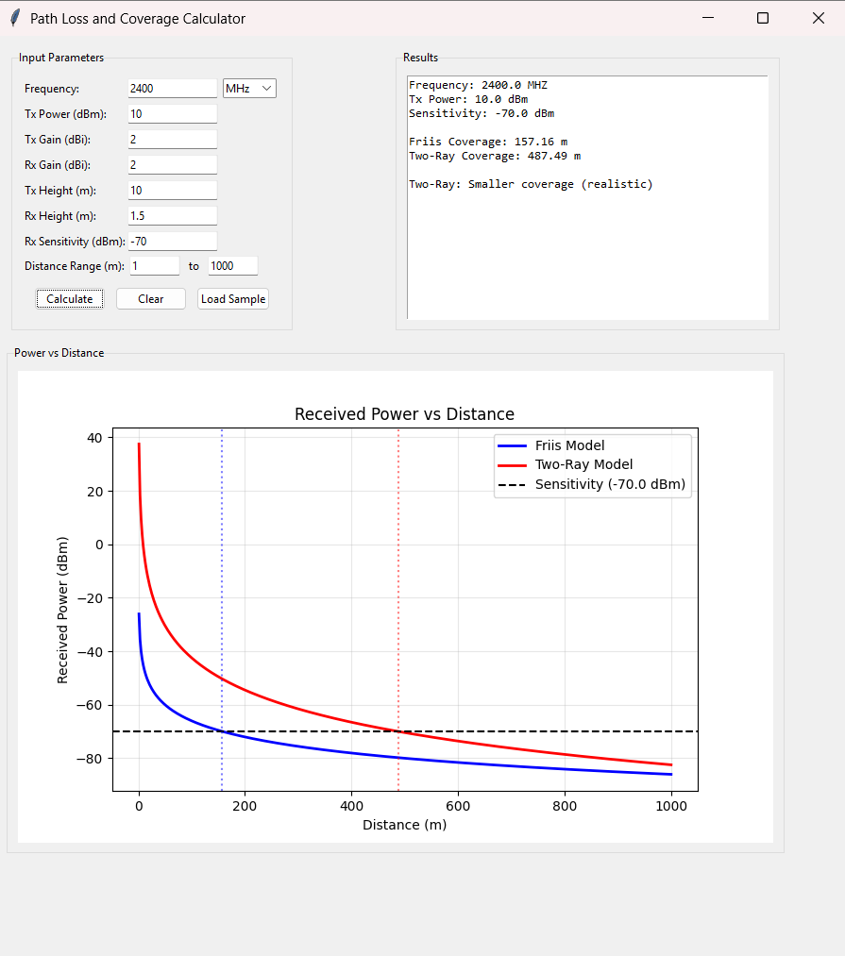

Based on the receiver sensitivity of -70 dBm, the Friis free-space model predicts a maximum range of only 157 meters. In contrast, the Two-Ray ground-reflection model forecasts a much larger 487-meter coverage because signal reinforcement from ground reflections boosts power at certain distances. However, this Two-Ray result is a theoretical best case; in real-world environments with obstructions like buildings and terrain, the actual reliable coverage is typically less than this optimistic prediction and can be closer to the more conservative Friis estimate.

